5 Right of Way
5.1 Turning left / giving way to oncoming traffic (10)
1. What is the right course of action?
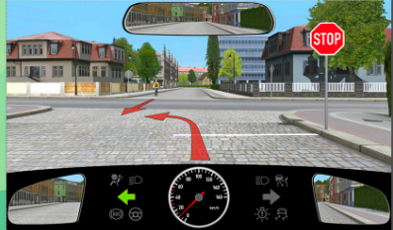 | - I have to wait at the stop line  - I have to allow the cyclist to pass through  - I may make the turn in front of the cyclist
2. What is the right course of action?
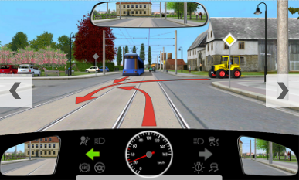 | - I have to allow the tram to pass through  - I have to allow the tractor to pass through  - I may not stop and wait on the rails
3. What is the right course of action? I may __________________
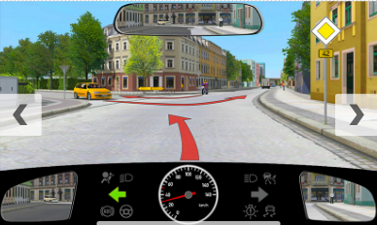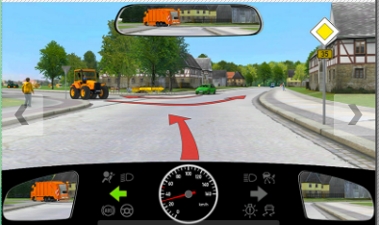
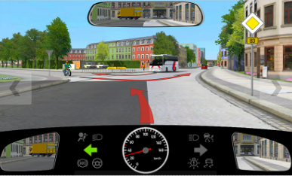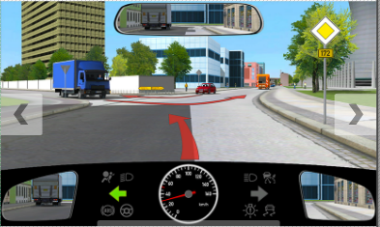
- Only turn after the car
- Turn before the tractor
- Be the first to make my turn
4. What is the right course of action?
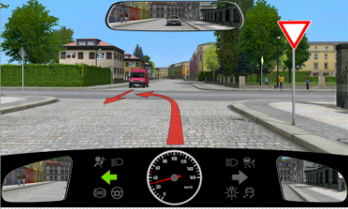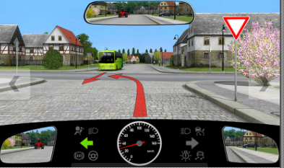
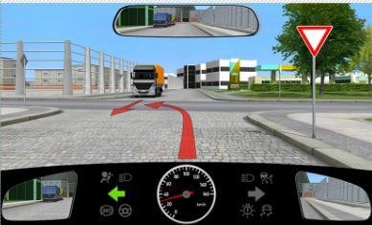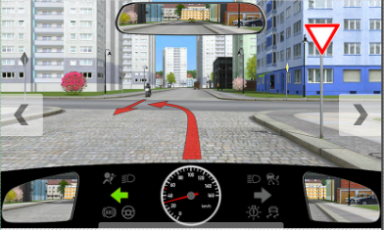
- I have to allow motorcycle to pass through
- I may turn before the motorcycle
5. What is the right course of action?
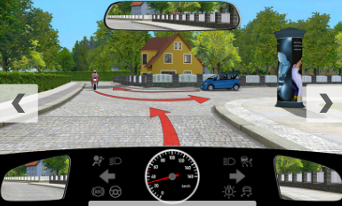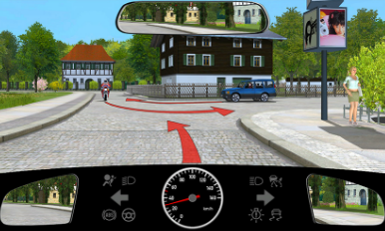
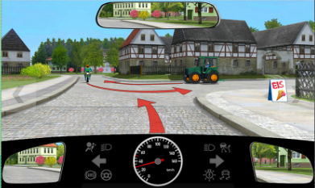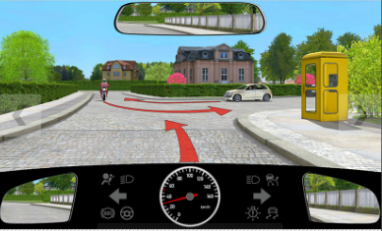
- I allow the white car to turn
- I allow the motorcycle to turn before me
- I am the first to proceed

6. What is the right course of action?
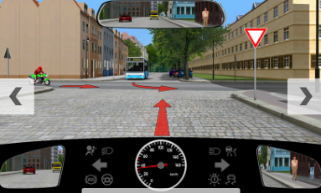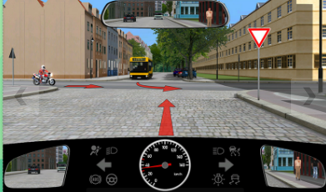
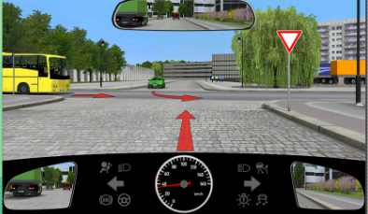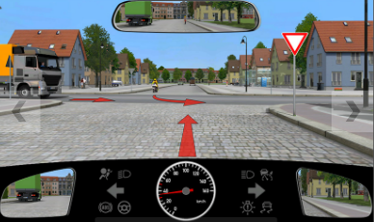
- I take priority before the motorcycle
- I have to allow the truck to pass through
- I have to allow the motorcycle to pass through
7. What is the right course of action?
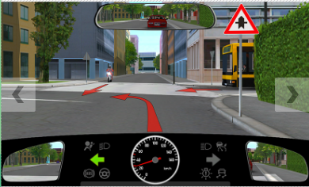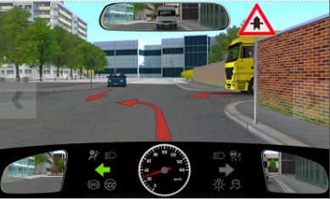
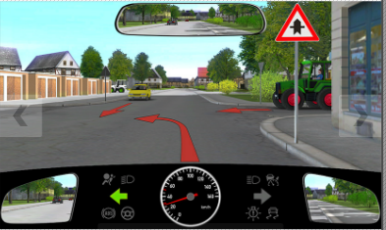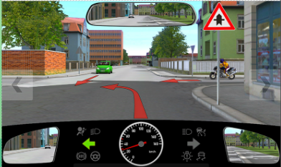
- I take priority before the motorcycle
- I have to allow the car to pass through
- I have to allow the motorcycle to pass through

8. What is the right course of action?
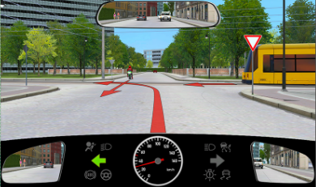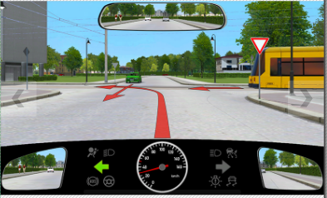
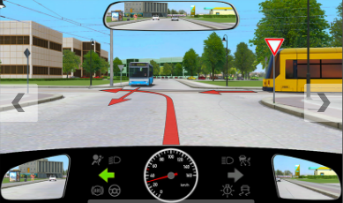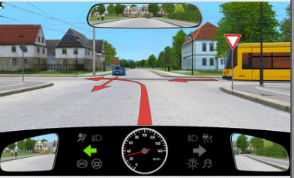
- I have to allow the tram to pass through
- I have to allow the car to pass through
- The tram must allow me to make the turn first
9. Why are you required to stop now? Because of the _____________
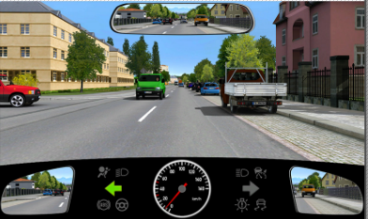 | - The cyclist  - Green vehicle  - Red vehicle

10. Why do you have to wait before the left turn?
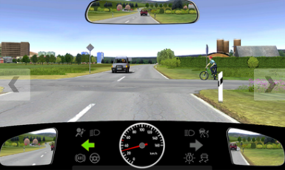 | - Motorbike  - Bicycle  - Car
----------------------------------------------------------------------------------------------------------------------------------------------
5.2 Right before left (19)
1.
5.3 Traffic signs showing right of way (22)
1.
5.4 Major road with turn (15)
1.
5.5 Roundabout traffic (7)
1. You are on a Roundabout. What should you remember?
- You must indicate to leave the Roundabout
- You are not allowed to stop on the roadway in a Roundabout
- You can only drive over a central Island if this is unavoidable because of your vehicle’s size
2 – 7 Pictures and Videos

